Temasek Polytechnic
School of Informatics and IT

Diploma in Information Technology (IT)

Software Requirement Specifications (SRS)

Project Particulars

Tutor | Mr Qi YuTao
Class | P04
Project Title | Hotel Management System

Project Team’s Particulars

Matric Number | Student Name
1704144C | Muhammad Ismail Bin Mohamed Ibrahim
1702625C | Soo Yuan
1703208G | Berwin Leong
1700803H | Ting Chao Chong

Revision History

Date | Version | Description | Author
<2/1/2019> | <1.0> | Do the first few data gathering, listing the function of the 3 modules | Soo Yuan,  Chao Chong,  Berwin,  Ismail
<3/1/2019> | <2.0> | List all the User characteristic, Constraints and functional requirements | Soo Yuan,  Chao Chong,  Berwin,  Ismail
<4/1/2019> | <3.0> | Do Data and User interface Requirement | Soo Yuan,  Chao Chong,  Berwin,  Ismail
<5/1/2019> | <4.0> | List All the possible Assumptions | Soo Yuan,  Chao Chong,  Berwin,  Ismail

Table of Contents

1. DISTRIBUTION OF WORKLOAD 4
2. OVERVIEW OF REQUIREMENTS 4
2.1 System Functions 4
2.2 User Characteristics 4
2.3 General Constraints 4
2.4 Functional Requirements 4
2.5 Data Requirements 4
2.6 User Interface Requirements 5
2.7 Assumptions 5
3 REFERENCES 6

DISTRIBUTION OF WORKLOAD

Requirement Gathering | Members
User Characteristics, Data Requirements, Assumptions | Berwin Leong
Room availability and booking module, General constraint, Assumptions | Ting Chao Chong
Housekeeping and staff management module, Function Requirements, Assumptions | Soo Yuan
Reporting Module, User interface Requirement, Assumptions | Muhammad Ismail Bin Mohamed Ibrahim

OVERVIEW OF REQUIREMENTS

System Functions
- Room availability and booking module
  - To allow guests to book the hotel room through online.
  - To show number of rooms available for the Guests to book.

- Housekeeping and staff management module
  - Allow administrator to record hotel staff’s personal details such as phone number and home address.
  - Show the staff’s duty types such as general maintenance, room maintenance, estate maintenance and security.

- Reporting Module
- Show the room status such as vacant, occupied or vacant but requested for cleaning.
- Able to list all guests and the rooms they stay in.
- Show the room statistics on the room occupancy on daily, weekly, monthly and yearly basis.
- Shows all staff duties and the work place they are allocated to.
- Allow system to let admin and reception staff to edit guest records and guest room.
- Allow admin to preview the report before printing the report.

User Characteristics
- End Users (Reception Staff)
  - Allow the user to access parts of the reporting module and room availability module.

- Management User
  - Allow users to access to all three, room availability and booking, housekeeping and staff management and reporting modules.

- Hotel Administrators
  - Allow users to access to all three, room availability and booking, housekeeping and staff management and reporting modules.
  - Additionally, able to access user’s account and login creating module.

General Constraints
- Software/System is not up to date.
- Malfunctions of the system due to various reason such as bug.
- System does not allow concurrent bookings/Usage.
- System require high maintenance due to long working usage
- Due to security purposes, data are not accessible by multiple devices, therefore if the device that stores the data is down, the data will be lost, unless backup is made.

Functional Requirements
- Room availability and booking module
  - Allow guests to search and book the available rooms and indicate how many children and adults is staying in a room on which day and what time.

- Housekeeping and staff management module
- The system shall allow the admin to see the hotel staff’s personal details such as contact number and staff ID.
- Allow admin to do amendment to staff details such as removing staff ID that are no longer working in the hotel for security purposes.
- System will show staff’s job scope and their individual responsibilities in the hotel.

- Reporting Module
- System display the room availability to staff in three aspect, vacant, occupied or vacant but requested for cleaning.
- System shows the staff who are the guest that stays in the particular room.
- System show a statistic of the number of people staying in the hotel in every time interval.
- System allow admin and reception staff to edit guest records and guest rooms.
- System allow admin to preview the report before printing.

Data Requirements
- Guest
  - Guest ID
    - Indicate the identification of each guest

  - Contact details
      - Phone number
      - Identity card
      - Email
      - Home and mailing address (street address, block number, house number, postal code, country)
  - Payment Details
    - Credit Card No
    - Credit Card holder name
    - Expiration Date
    - Cash
  - Checking Details
    - Check in date and time
    - Desired check out date and time
  - Additional Remarks/Requirements
    - king size bed queen size
    - smoking or non-smoking room

- Staff
  - Staff name
  - Staff ID
  - Date of Birth
  - Bank Account Number
  - Home Address
  - Contact number
  - Duty types the staff can do
- general maintenance
- room maintenance
- estate maintenance
- security

User Interface Requirements
Home Page
- Shows the Hotel Main page
- Display information of the hotel room provided by the hotel
- Show Guest the hotel information and Contact details
- Allow guests to find rooms on specific dates
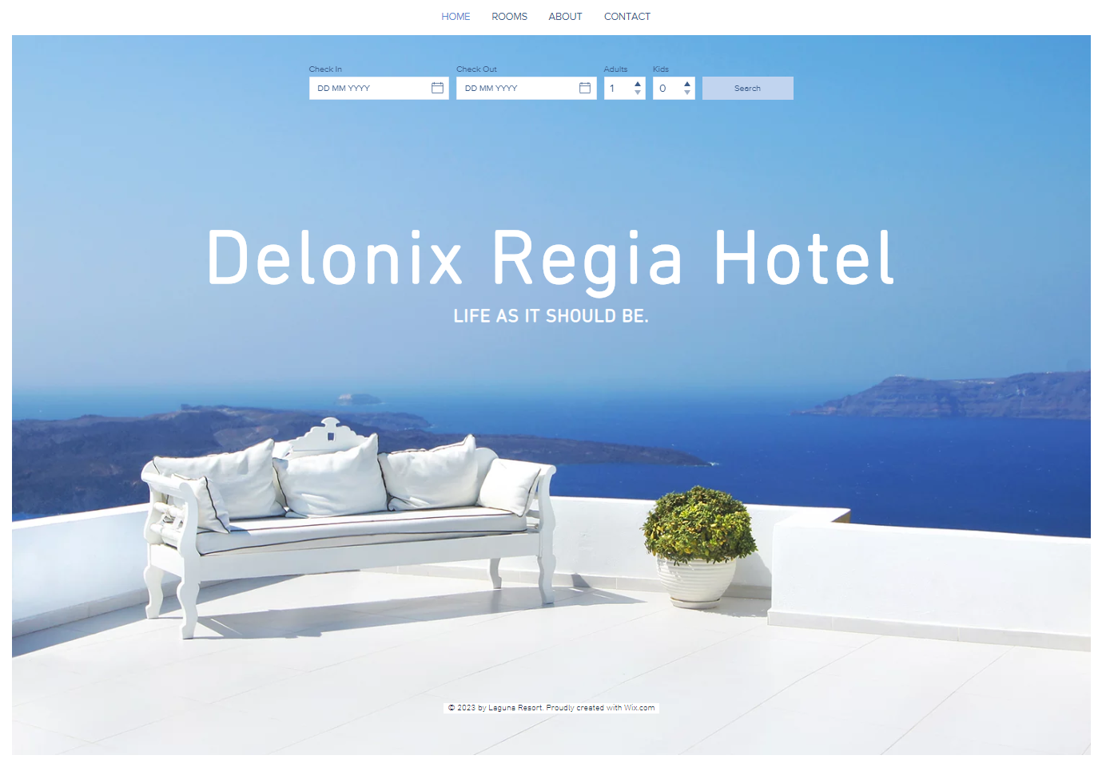

Booking Room Page
- Shows all types of room categories
- Show Available rooms on specific days
- Allow Booking of hotel rooms
- Display available amenities by the specific room.
- Allow guests to search for hotel rooms in specific day
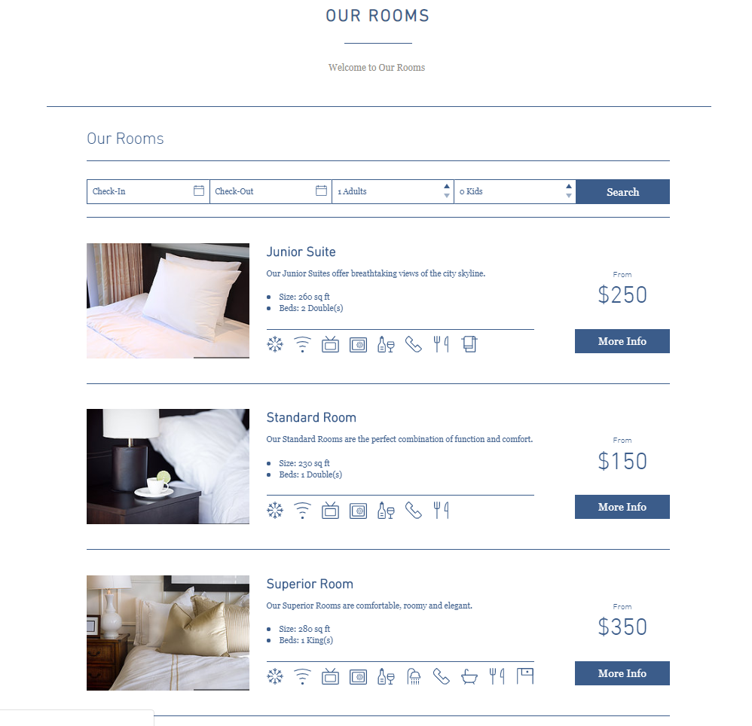

Contact Hotel Page
- Display Hotel location
- Show the guests multiple ways to contact the hotel
- Allow guest to send in enquiries.
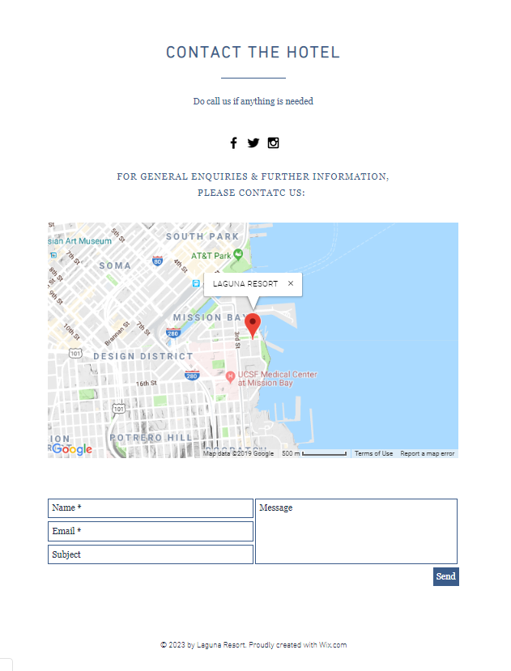
About Page
- Display Hotel Background
- Shows Hotel Amenities and Facilities

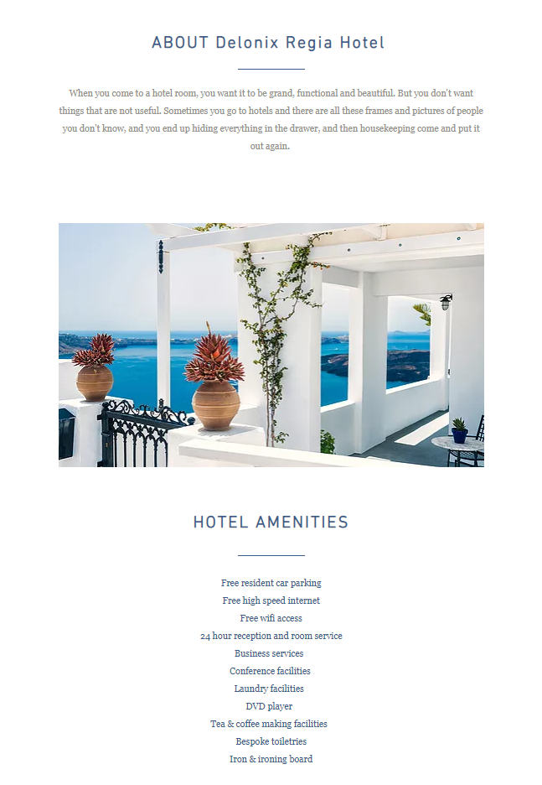

Assumptions
- System is working finely
- Data is stored correctly in the system
- Systems indicates all the available rooms
- Systems shows the correct information of staff and Guest details.

REFERENCES
Wixpress. (n.d.). Laguna Resort Website Template | WIX. Retrieved from https://www.wix.com/website-template/view/html/1771?siteId=db384420-4c5d-4fae-b9d4-de144d4fcb53&metaSiteId=55b39d6a-c7ec-436f-a889-52aa96c81c25&originUrl=https%3A%2F%2Fwww.wix.com%2Fwebsite%2Ftemplates%3Fcriteria%3Dhotel%26page%3D4

